Sam McDowell

7/3/2020

Lab 3.1

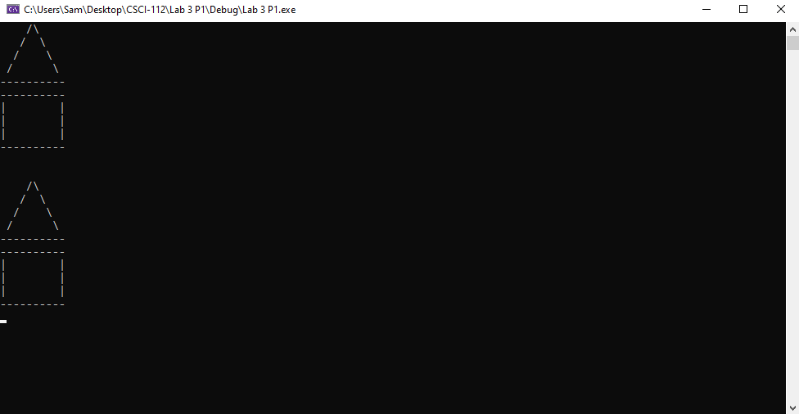

# Transcription:

/\

/ \

/ \

/ \

----------

----------

| |

| |

| |

----------

/\

/ \

/ \

/ \

----------

----------

| |

| |

| |

----------